Sheet 5

Computing algorithms
Q1:
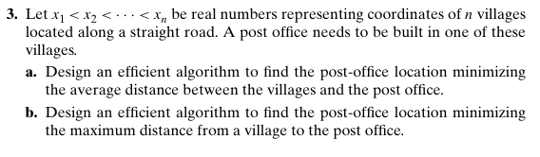
Q2:
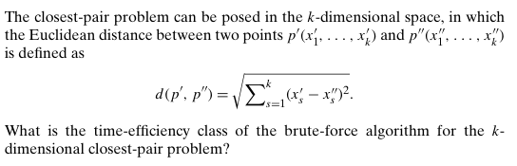
Q3:
Apply the brute force- knapsack problem on the following input
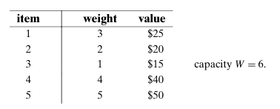
Q4:
Apply the brute force assigning problem algorithm on the following input:
 | Job 1 | Job 2 | Job 3 | Job 4
Person 1 | 1 | 12 | 10 | 6
Person 2 | 8 | 4 | 5 | 4
Person 3 | 4 | 5 | 6 | 1
Person 4 | 1 | 4 | 6 | 7

